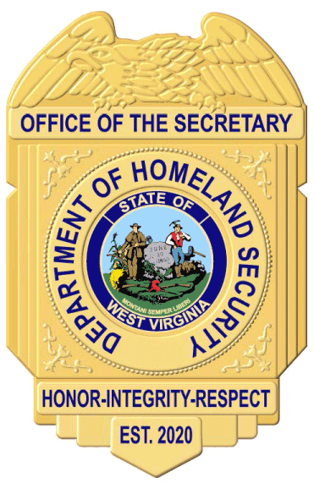

OFFICE OF THE SECRETARY
DOUGLAS P. BUFFINGTON, II
ACTING CABINET SECRETARY
Email: Douglas.P.Buffington@wv.gov
Telephone: 304-558-2930
Website: dhs.wv.gov

STATE OF WEST VIRGINIA
DEPARTMENT OF HOMELAND SECURITY
Building 1, Suite W-400
1900 Kanawha Blvd., East
Charleston, West Virginia 25305
Established May 28, 2020

September 4, 2025

103 CSR 06
Title 103
Legislative Rule
State Fire Marshal
Series 6
“Standards for the Certification and Continuing Education of Municipal, County, and Other Public Sector Building Code Officials, Building Code Inspectors and Plans Examiners”

103 CSR 06, the legislative rule titled “Standards for the Certification and Continuing Education of Municipal, County, and Other Public Sector Building Code Officials, Building Code Inspectors and Plans Examiners” was Notice filed on June 23, 2025, with the Secretary of State.

The written public comment period ended July 23, 2025, at 12:00 pm. No public comments were received.

Subsequently, the rule was Agency Approved filed on July 23, 2025.

The State Fire Marshal wishes to explore statutory changes to the West Virginia Code prior to making changes to the legislative rule.

As such, the State Fire Marshal has decided to withdraw the legislative rule for further consideration.

