July 26, 2021

Robert Likins
Pet Industry Joint Advisory Council
1615 Duke Street, Suite 100
Alexandria, VA 22314

Dear Robert Likins,

I am writing to confirm that I received your comments on the 2021 Farm Bill pertaining to the Commercial Feed Rule §61-05. We understand your concern with the amount of money that is being paid by your stakeholders and consumers for each product. As you will note, the legislative rule makes no changes to the amount that is charged for each pet food. Moreover, the requirement to collect a fee to support the Spay-Neuter program is statutorily imposed, and therefore the Department has no control over that fee.

We appreciate your comments, and we will consider all comments and recommendations that we receive on the proposed rule and look forward to working with all consumers and vendors in our state. Thank you for taking the time to comment and we look forward to working with all our stakeholders in the future.

Sincerely,

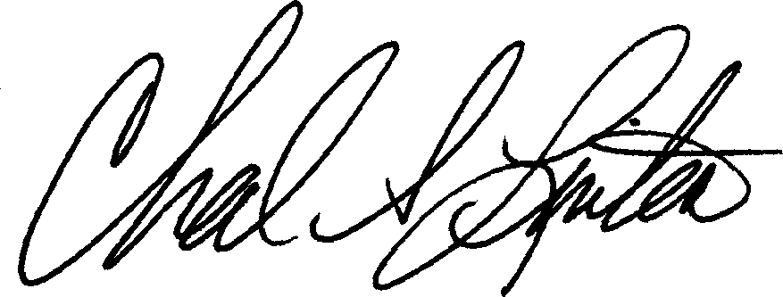

Chad S. Linton
Deputy Director of Regulatory Operations
Regulatory and Environmental Affairs Div.

