76CSR3

TITLE 76
INTERPRETIVE RULE
WEST VIRGINIA BUREAU OF SENIOR SERVICES

SERIES 3
WEST VIRGINIA STATE PLAN FOR AGING- TITLE V

§76-3-1. General.
1.1. Scope. - - The State Plan for Aging Programs includes all assurances and plans to be conducted by the Bureau of Senior Services under the provisions of the Older Americans Act of 1965, as amended. The Bureau of Senior Services is primarily responsible for the coordination of all the major responsibilities of developing and administering a comprehensive and coordinated system of services and activities for providing a positive impact on the lives of elderly people with the service area.
1.2 Authority. - - W.Va. Code §16-5P-1 et. seq.
1.3 Filing Date. – June 19, 2018.
1.4. Effective Date. – July 18, 2018
§76-3-2. Incorporation By Reference.

The West Virginia State Plan for Aging Programs is hereby incorporated by reference as an interpretive rule. This document is available from the Secretary of State’s Office or the West Virginia Bureau of Senior Services.

WEST VIRGINIA BUREAU OF SENIOR SERVICES
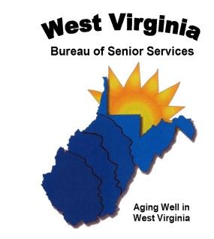

OLDER AMERICANS ACT

WEST VIRGINA STATE PLAN FOR THE
SENIOR COMMUNITY SERVICE EMPLOYMENT PROGRAM

PROGRAM YEARS JULY 1, 2020 – JUNE 30, 2023
(Stand- Alone)

Table of Contents
SECTION 1. Overview of the Senior Community Service Employment Program and Purpose of the State Plan 4
SECTION 2. Economic Projections and Impact 6
Long-term Projections for Jobs in Industries and Occupations 6
Strategic Training Plan for Participants to be placed in Unsubsidized Employment 10
State Current and Projected Employment Opportunities 11
SECTION 3. Service Delivery and Coordination 17
Action and Coordination with Other Programs 17
Long-Term Strategy to Engage Employers to Place Participants in Unsubsidized Employment 19
Long- Term Strategy for Serving Minorities under SCSEP 20
Community Service Needs 21
Long-term Strategy to Improve SCSEP Services 22
Strategy for Continuous Improvement in Entered Employment of Performance 23
SECTION 4. Location and Population Served, Including Equitable Distribution 25
Localities and Populations Most in Need of the Type of Projects Authorized by Title V 25
Equitable Distribution Changes from Prior Year 25
Equitable Distribution Imbalances and Corrective Steps 28
The State’s Long-Term Strategy for Achieving Distribution of SCSEP Positions within the State 28
Ratio of Eligible Individuals in Each County and State Total Eligibility Population 29
Relative Distribution of Eligible individuals 31
Avoid Disruptions 38
APPENDICES 39
Appendix A -West Virginia Area Agencies on Aging 40
Appendix B- Workforce WV Development Board 41
Appendix C- Delegation of Authority State Plan Letter 42
Appendix D- Public Comments 43
Appendix E- Occupational Demand 44
Appendix F- Top 15 Occupations in Demand 45
Appendix G- Population by Age Group 46
Appendix H – Labor Force Participation by Age Group 47
Appendix I- Average Turnover Rate by Age 49

WEST VIRGINIA SENIOR COMMUNITY SERVICE EMPLOYMENT PROGRAM
STATE PLAN FOR PROGRAM YEARS JULY 1, 2016 THROUGH JUNE 30, 2020

SECTION 1. Overview of the Senior Community Service Employment Program and Purpose of the State Plan
In 2014, President Barack Obama signed the Workforce Innovation and Opportunity Act (WIOA) (P.L. 113-128) into law, formally overhauling and reauthorizing the expired Workforce Investment Act (WIA) of 1998. President Obama signed the WIOA following swift passage and overwhelming bipartisan support for the bill in both the U.S. House of Representatives and the Senate.

The U.S. Department of Labor (USDOL), state workforce agencies, local workforce areas, and other stakeholders continue to implement the changes under WIOA, which became effective July 1, 2015.

The Senior Community Service Employment Program (SCSEP) also known as Title V, is authorized under the Older Americans Act (OAA) as amended in 2006, and administered by the U.S. Department of Labor, Employment and Training Administration (DOLETA). The DOLETA distributes SCSEP funds to nineteen (19) National SCSEP Grantees and fifty-six (56) State and Territorial Grantees. The National Grantees operate across multiple state jurisdictions and receive 78% of SCSEP funds. State and territorial SCSEP Grantees receive the remaining 22% of SCSEP funds.

SCSEP is the only grant program designed specifically to serve low-income older workers, age fifty-five (55) and older, by providing job training through community-based organizations and government agencies. The goals of the program are two-fold, to provide community service and to promote self-sufficiency by placing individuals in unsubsidized employment.

Program-eligible older workers must be residents of West Virginia, fifty-five (55) years of age and older, unemployed, with a total family income that does not exceed 125% of the federal poverty guidelines, currently $15,613 for an individual. Service priority is given to individuals meeting one or more of the following criteria:

- Disabled
- Limited English Proficiency
- Low Literacy Skills
- Reside in a Rural Area
- Veterans or Veterans’ Spouses
- Low Employment Prospects
- Failed to Find Employment after using WIOA Services
- Homeless or at Risk of Homelessness
- Minority Individuals
- Poverty Level or Below
- Eligible individuals receive part-time, subsidized job training through community service assignments (CSA) at non-profit organizations or governmental entities.

The West Virginia Bureau of Senior Services (Bureau) administers the State SCSEP Grantee program, contracting with Preston County Senior Citizens, Inc. to provide SCSEP services to eleven (11) Counties. In addition, the National Grantee, National Council on Aging, provides SCSEP services in West Virginia to the remaining 44 counties.

The SCSEP State Plan outlines a four-year strategy covering Program Year July 1, 2020-June 30, 2023 for the statewide provision of community service employment and other authorized activities for eligible individuals under the SCSEP. The four-year strategy must specifically address the following:

- Economic Projections
- Long-Term Projections for Jobs in Industries and Occupations
- Strategic Training Plan for Participants to Be Placed in Unsubsidized Employment
- State Current and Projected Employment Opportunities
- Service Delivery and Coordination
- Action and Coordination with Other Programs
- Long-Term Strategy to Engage Employers to Place Participants in Unsubsidized Employment
- Long-Term Strategy for Servicing Minorities under SCSEP
- Community Service Needs
- Long-Term Strategy to Improve SCSEP Services
- Strategy for Continuous Improvement in Entered Employment of Performance
- Location and Population Served, Including Equitable Distribution
- Localities and Populations Most in Need of the Type of Projects Authorized by Title V
- Equitable Distribution Changes from Prior Year
- Equitable Distributions Imbalances and Corrective Steps
- The State’s Long-Term Strategy for Achieving Distribution of SCSEP Positions within the State
- Ratio of Eligible Individuals in Each Area to the Total Eligible Population in the State
- Relative Distribution of Eligible Individuals
- Steps to Avoid Disruptions to Service for Participants

During the 2016 reauthorization of the Older Americans Act, changes were made to the performance indicators. This reauthorization changed the follow-up on three of the current Core Performance Measures and added a new Core Measure. Changes were in the following Core Measures, with the new Core Performance Measure being Customer Satisfaction:
- Common Measures Entered Employment
- Common Measures Employment Retention; and
- Common Measures Average Earnings
Strategies for achieving these adjustments will be that both the National and State will continue to follow up with enrollees upon their exit and will now follow-up quarterly to actively capture information as required by the Core Measures. Follow up dates will be updated, and emphasis will be put more in the beginning of the program to ensure that enrollees, host agencies and employers are aware of the culture. Both State and National Grantees will continue to ensure that enrollees are fully equipped with the necessary tools (i.e., functional resumes, computer literate, functional workforce profile etc.) to warrant that, once employed, that employment is sustained. Grantees will continue to adhere to the performance measures that are set forth by the WIOA and will continue to meet the performance goals by the continuance of excellent rapport with Workforce, host agencies and potential employers.

The OAA and federal regulations require the Governor of each state to develop a strategic four-year State Plan in collaboration with the national SCSEP grantees, the aging network, and workforce entities operating within their state. Because the West Virginia Bureau of Senior Services is West Virginia’s State Unit on Aging (SUA), Governor Jim Justice delegated authority to Commissioner Robert Roswall to submit the State Plan on his behalf to USDOL/ETA. (Appendix C)

SECTION 2. Economic Projections and Impact

Long-term Projections for Jobs in Industries and Occupations

According to the United States Census Bureau, West Virginia’s population totaled 1,852,994 during the last conducted census in 2010. The total number of West Virginians age 55 and older totaled 562,229, comprising 30.4% of the state’s total population. Table 1 illustrates the total population categorized by age ranges.

Table 1
Total Population Categorized by Age Range
Age Range | Total | Percentage
55 to 59 | 139,368 | 7.5%
60 to 64 years | 125,457 | 6.8%
65 to 69 years | 91,728 | 5%
70 to 74 years | 71,792 | 3.9%
75 to 79 years | 54,725 | 3%
80 to 84 years | 43,238 | 2.3%
85 years and over | 35,921 | 1.9%
(Source: Census Bureau, fact finder, 2010)

Figure 1 shows the age distribution of West Virginia’s working age population in all industries that are broken down into twenty sectors. These sectors include Finance and Insurance; Real Estate; Professional; Scientific, and Technical Services; Management of Companies and Enterprises; Administrative Support; Waste Management and Remediation Services; Educational Services; Health Care and Social Assistance; Arts, Entertainment, and Recreation; Accommodation and Food Services; Other Services; and Public Administration.

Figure 2 narrows down the population results showing only SCSEP’s target audience (55+) in all industries. As depicted in the figures, there is evidence of continuous increase in the representation of (55+) seniors entering the workforce.

Figure 1.
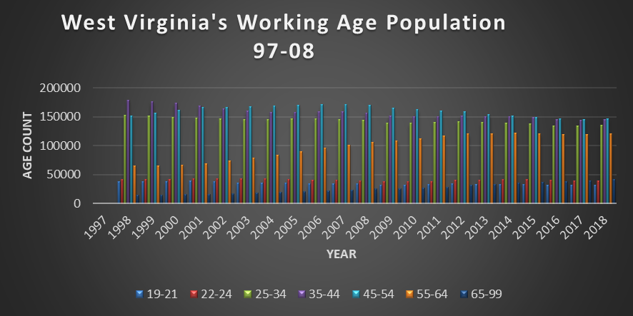

Figure 2
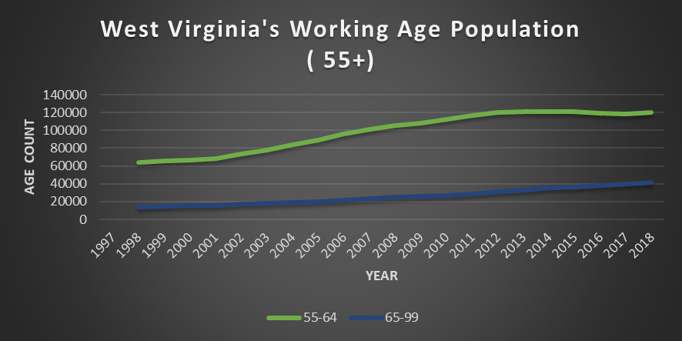

(Source: Figure 1 & 2, QWI Explorer Appendix 97-2018)

According to the Quarterly Workforce Indications (QWI), out of the twenty industries, the industry sectors that represented the largest numbers of employed seniors during 2018 were Health Care and Social Assistance (20%), Education Services (13%), Retail Trade (11%) and Manufacturing (8%). These sectors were the top four employers for older workers 55+ during 2018. Table 2 illustrates the industries during 2018 that had the largest number of older workers.
Table 2
Industry Sector Employment of Older Working West Virginians
55+ in 2018

(Source: Table 2; QWI,NAICS Sectors, 2018)

Information from the QWI was narrowed down to display which of the 20 Industry Sectors had the highest percentage of hiring older workers (55+). Industry Sectors with the largest percent of new hires of older workers during 2018 were Construction (17%), Health Care and Social Assistance (11%) and Retail Trade (10%). Table 3 illustrates the industries during 2018 that had the largest number of 55+ seniors.

Table 3
Industry Sector of New Hires of Older Working West Virginians 55+ 2018

(Source: QWI, NCAICS Sectors, 2018)

From the information gathered in Table 3, the staffing patterns from the top three Industry Sectors of New Hires show employment in Construction (17%), Healthcare and Social Assistance (11%) and Retail Trade (10%). We can forecast that these industries will continue to hire older workers, thus providing employment opportunities in the following Equal Employment Opportunities (EEO) Occupations Groups based off the Industry Sector of New Hires: Transportation, Natural Resources, Contruction & Maintenance Occupations, Sales and Office Occupations, Service Occupations, Education, Legal, Community Service, Arts & Media Occupations, Management, Business & Science. EEO Occupational Groups are categorized into 14 groups and further categorized into nine job categories. Table 4 illustrates the twelve Occupational Groups that were narrowed down from the top three Industries.

Table 4
EEO Tabulation 2006-2010 Occupation Code
( Source: EEO Tabulation 2006-2010 (5yr ACS)

Strategic Training Plan for Participants to be placed in Unsubsidized Employment

In order to maximize SCSEP participant placement in unsubsidized employment in high demand jobs, the statewide SCSEP network will focus their on-the-job training opportunities and host agency recruitment efforts on agencies that can provide training for the types of occupations that are listed in Table 4 that are forecasted based on Industry Sector of New Hires 2018 to hire older workers.

Training opportunities will be increased to provide a variety of opportunities that have a higher percentage of developing into unsubsidized employment. Training for computer literacy will continue to be at the forefront, as this is a necessity in a majority of the occupations that forecast continued employment. Computer training opportunities are provided through many entities, such as local American Job Centers (AJC), local Community Colleges, and public libraries. When appropriate, program coordinators and host agencies will encourage participation in specialized computer training opportunities.

Access to training classes offered by the local American Job Center and other non-profit organizations will help increase the skills that enrollees will need to continue to pursue employment.

Another strategy for older workers to be placed into unsubsidized employment would be to look into occupations that require minimum training, as this would help the statewide SCSEP meet the employment goals listed in the core measures that are set forth by DOL.

State Current and Projected Employment Opportunities

Per the Workforce West Virginia (WFWV), Labor Market Information (LMI) Ten(10) year projections of the high demand occupations that require minimum education and fit our SCSEP participants’ education and training levels include the following:

    - Bus Drivers, Transit and Intercity
    - Customer Service Clerks
    - Social and Human Service Assistants
    - Community Health Workers
    - Animal Caretakers
    - Post Secondary School
    - Personal Care Aides
    - Home Health Aides
    - Rehabilitation
    - Janitors
    - Counter Attendants

Some of these occupations require less than a high school education. Others require a high school diploma or some college. Per the data received from SPARQ, the majority of our participants meet the education requirements for the jobs listed above. Hourly wages for the listed occupations start at a minimum of $10.41.

Table 5
Education | PY 18 Q4 Final YTD %
8th grade and under | 2
9th grade – 11th grade | 15
High school Diploma | 49
1-3 years college | 21
Post- Secondary certificate | 0
Associate’s Degree | 1
Bachelor’s Degree or equivalent | 11
Some graduate School | 1
Master’s Degree | 1
Doctoral Degree | 0
( Source: SPARQ, Quarterly Progress Report Program Year 2018, Quarter 4 Final)

Table 5a provides employment projections based on eight education levels in West Virginia.

Table 5A : Projections by Level of Education
(Figure shows employment projections based on eight education levels for the year 2026.)
2016-2026 Occupational Projections by Level of Education
Education Level | 2016  Employment | 2016% of  Workforce | 2026 Projected Employment | 2026% of  Workforce
Less than high school | 204,905 | 27.18% | 217,467 | 27.34%
High school diploma or equivalent | 321,770 | 42.68% | 330,507 | 41.55%
Some college, no degree | 935 | 0.12% | 1,036 | 0.13%
Postsecondary non- degree award | 27,534 | 3.65% | 29,974 | 3.77%
Associate degree | 29,988 | 3.98% | 32,412 | 4.07%
Bachelor’s degree | 75,584 | 10.02% | 81,073 | 10.19%
Master’s degree | 12,755 | 1.69% | 14,523 | 1.83%
Doctoral or professional degree | 10,027 | 1.33% | 11,012 | 1.38%
Not applicable | 70,476 | 9.35% | 77,496 | 9.74%
Total | 753,974 |  | 795,500
(Source: Workforce West Virginia, Occupational Employment Statistics (OES)

Table 6 illustrates the required level of education, on-the job training, work experience required, and growth rate of each occupation.

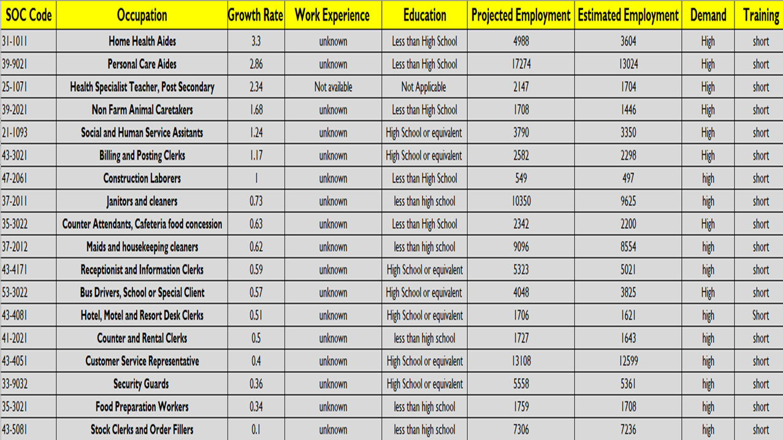
Table 6
( Source: WV LMI Long term Occupation Projections 2016-2026)

The Workforce West Virginia (WFWV) office divides the state into seven geographic regions that covers all 55 counties shown on the map in Appendix B. As shown below, each region shows their specific region’s greatest growth occupation. Not only does the WFWV consist of seven (7) geographic regions, the seven (7) regions each have at least one comprehensive AJC, at minimum. In total, the seven regions hold Ten (10) comprehensive centers, five (5) satellite centers and seventeen (17) affiliate sites throughout the State. One of the goals of the AJCWV is to offer job seekers and employers ready access to the many workforce development resources available in a local region. The WVWF office offering resources equally across the state as stated above, The SCSEP Network will continue to utilize resources such as transition programs, adult displacement resources, resume enhancement, computer classes, mock interviews and all other events that are offered at the AJCWV.

Within the seven (7) regions that WFWV has divided the state into, each region shows that Host Agency recruitment and enrollee training will have to be individualized to adapt to that particular Region’s occupational demands. The SCSEP Network will maintain working relationships with all WFWV offices to obtain relevant employment and training information that pertains to that Region. Sub-grantees will continue to inform enrollees of their specific region’s occupational projections.

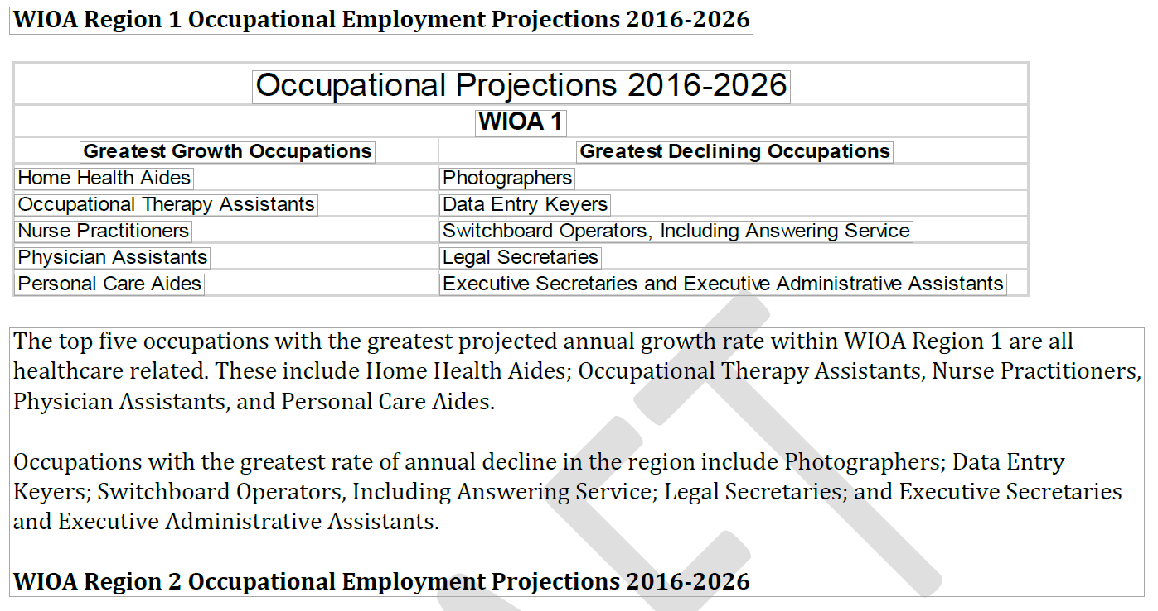
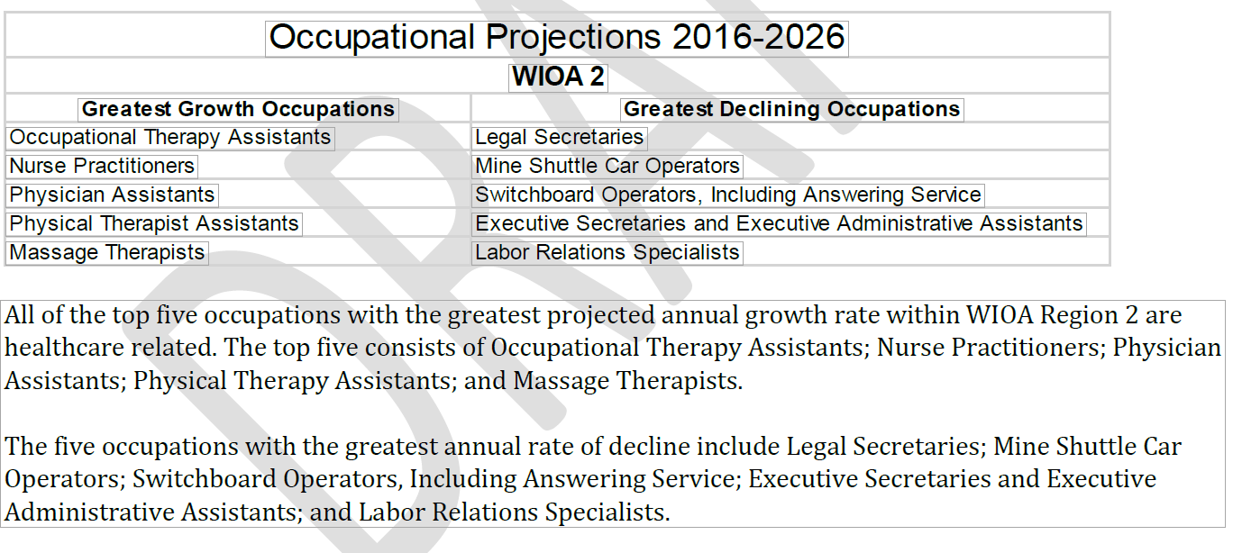
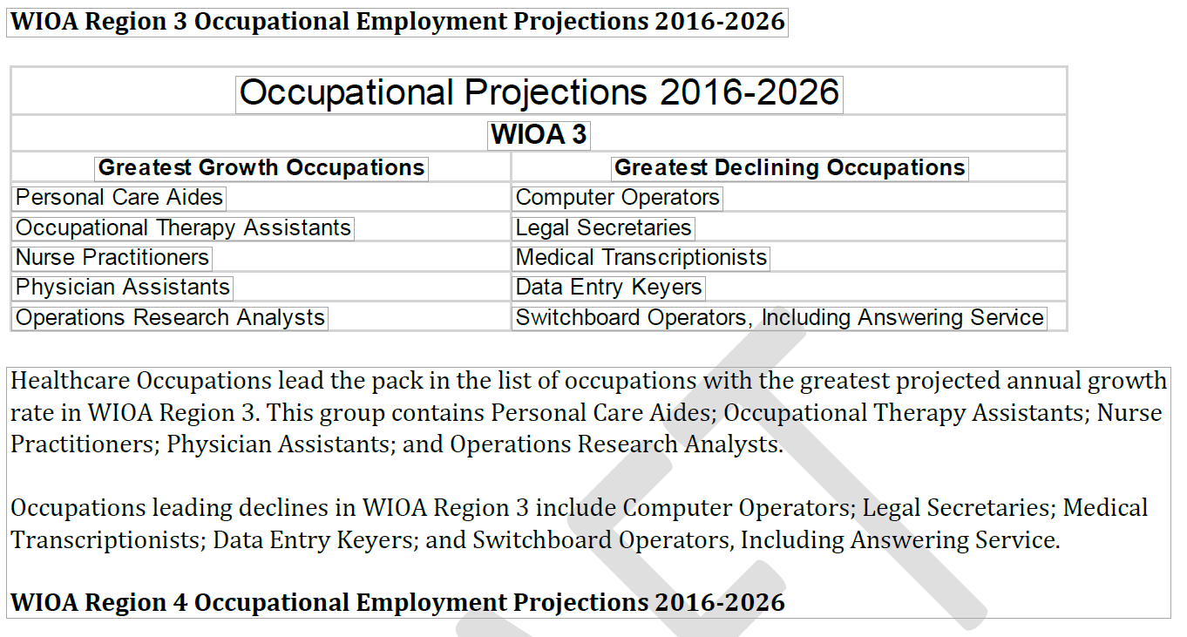
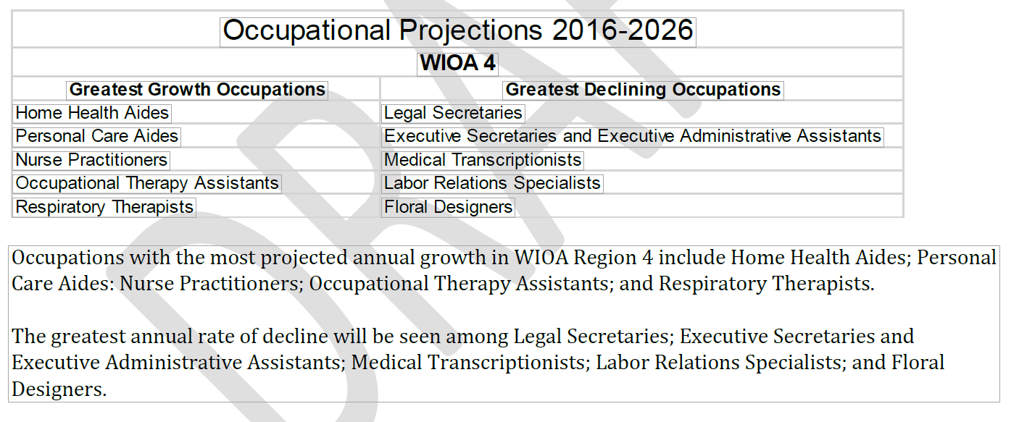
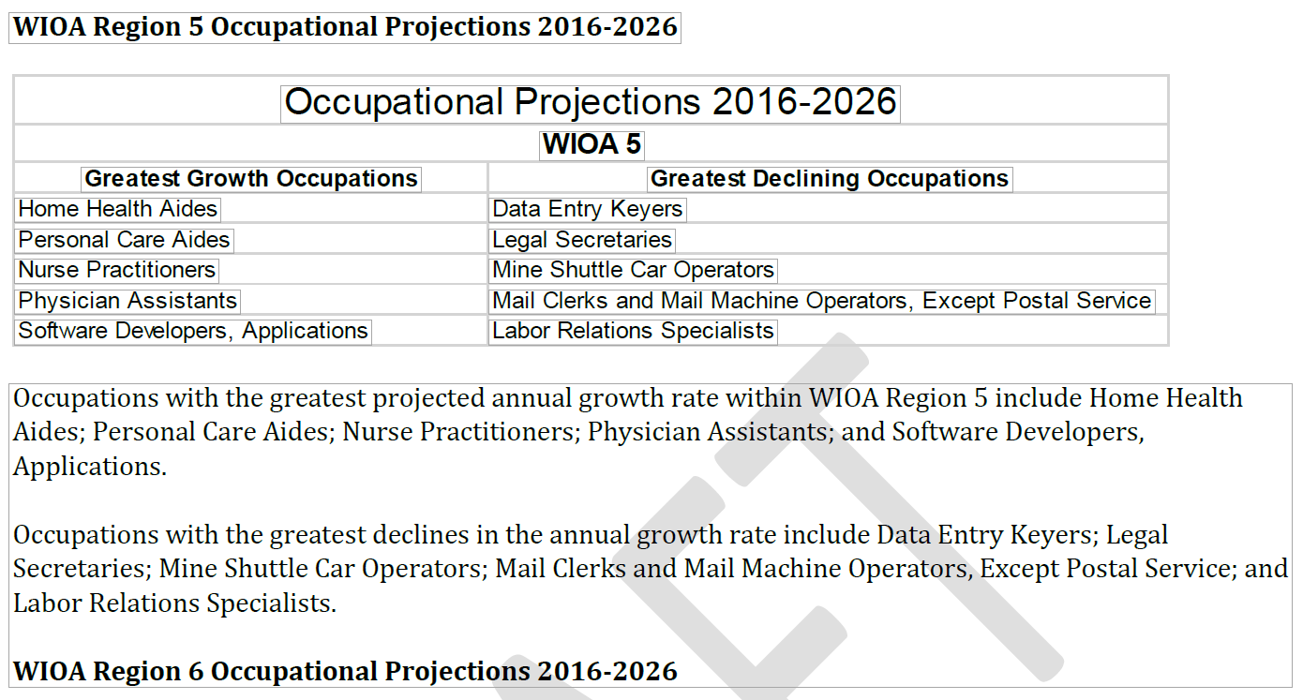
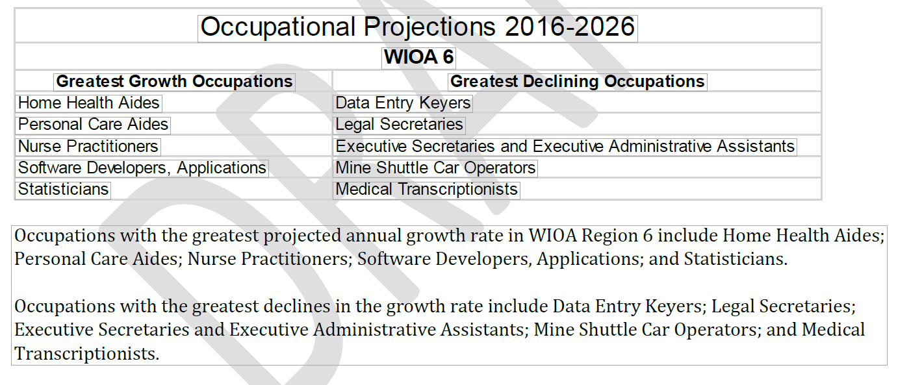
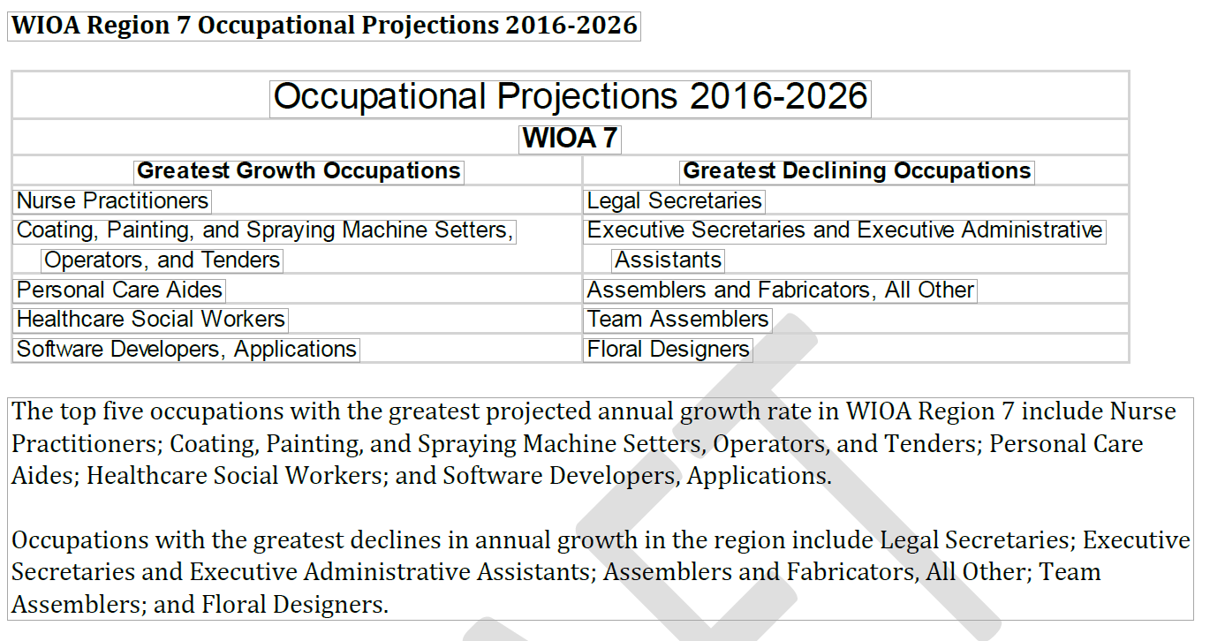

SECTION 3. Service Delivery and Coordination

Action and Coordination with Other Programs

West Virginia’s statewide SCSEP network includes the State Grantee and one National Grantee operating in WV. Communication with this network is accomplished through email and teleconference as needed throughout the Program Year. The State Grantee is the West Virginia Bureau of Senior Services, which provides a multitude of services for older Americans in West Virginia under the Older Americans Act (OAA). As the designated State Unit on Aging, the Bureau administers all OAA services throughout the 55 counties that are tailored to Older West Virginians. The Bureau maintains contracts with each of the 55 County Aging Programs, three (3) Statewide Aging & Disability Resource Centers and four (4) Area Agencies on Aging. The Bureau’s mission is to be West Virginia’s premier advocate for the provision of in-home and community-based services for the state’s seniors and others served by our programs and to be a faithful steward of the federal and state monies entrusted to our care for the provision of services throughout West Virginia.

Through a Memorandum of Understanding, the WV Statewide SCSEP network, a mandated partner, partners with the local Workforce Investment Boards operating the American Job Center (AJC)/ One-Stop Centers. The mission and vision between the AJC and WV SCSEP are to empower area employers, individuals and communities to prosper and grow the region’s economy through a workforce development system that is inherently customer-centered, seamless and effective. The mission is to establish a workforce system that provides data-driven and employer-validated talent solutions through the integration of education, workforce and economic development resources across the systems. Its vision is assisting individuals in obtaining employment.

West Virginia’s American Job Centers (AJC’s)/One-Stops are currently located within the local Workforce centers in West Virginia. All SCSEP information is disseminated throughout the AJC for other programs and to the general public. The WV Statewide SCSEP network will continue to work closely with the AJC’s to utilize the partners’ resources that are tailored to SCSEP’s target audience by co-enrolling and by providing SCSEP’s program eligibility requirements, priorities and training slots availability. SCSEP will continue to have a weekly presence at the AJC/One-Stop. The Statewide SCSEP network will continue to require enrollment of SCSEP enrollees into the Local Workforce to ensure that enrollees are abreast of employment opportunities in their areas. The network will also continue to utilize all trainings and job fairs that are offered at the Local AJC’s and will also participate/relay information from other resources outside of the AJC’s One-Stop Partners. The WV Statewide SCSEP network will also encourage enrollees who are approaching their durational limit to enroll in other training programs to ensure a continuous improvement of skills that enrollees receive. As needs become prevalent, the WV Statewide SCSEP network will encourage AJC’s to become Host Agencies and/or consider enrollees for employment opportunities.

One of the barriers with the AJC’s/One-Stop Centers in West Virginia is that they are underutilized. A solution to improve coordination with the One-Stop delivery System would be to coordinate data information sharing with local Workforce West Virginia offices to obtain information on age-eligible persons who visit the AJC.

The Bureau is a member of the Interagency Collaborative Team (ICT), which is comprised of leadership representing workforce target groups. One of the primary goals of this group is to enhance communications, resource sharing and program standardization. Additionally, the Bureau sits on the WV Workforce Development Board, which is comprised of key state players within the workforce arena, including legislators, members of the Governor’s Cabinet, labor leaders and corporate representatives. The main purpose of this group is to approach the system-based issues that require changes in law or formal regulations pertaining to workforce initiatives. As stated, these entities are comprised of private and public key stakeholders. The WV Statewide SCSEP network will continue to maintain relationships and participate in meetings and events to guarantee that SCSEP is considered for program partnership, employment opportunities for enrollees and ultimately remains relevant in discussions regarding barriers to employment. The Bureau will remain an advocate for Older Workers in these groups.

Partnerships will be increased with organizations that provide resources on how to alleviate employment barriers throughout the state, such as transportation, age discrimination, fear of health care being discontinued due to program participation, fear of losing subsidized housing benefits, just to name a few. The Area Agencies on Aging (AAAs) who contract with county aging providers continue to be utilized and researched to determine what additional employment barriers seniors in rural/urban counties might face. Furthermore, the Bureau will take a more active approach with reaching out to AAA’s to also determine additional resources and/or training opportunities that may be available in covered areas.
The WV Statewide SCSEP network will continue to utilize the Labor Market Information (LMI) data that is county specific to ensure that enrollees are receiving the most updated training to warrant eligibility for those high demand occupations in growing industries as discussed in the “Economic Projections” of this report. Ultimate goal for enrollees is that when they leave the program, they will be better off than when they entered. Workforce WV provides quarterly information regarding the job market, as they are the clearing house of employment opportunities for State, Private and non-profit sectors. This information will be researched by the Grantee to ensure that Sub-Grantees are providing enrollees with the essential tools needed to be marketable. Also, resources such as O*net Online will be utilized to determine the necessary skills needed for different occupations that enrollees may be interested in.

Long-Term Strategy to Engage Employers to Place Participants in Unsubsidized Employment

West Virginia’s local SCSEP projects will continue to recruit public and non-profit organizations in the communities that are covered. Local Projects will continue to advocate for older workers through presentations, brochure dissemination, poster dissemination, job fair and community events participation and increasing awareness of program vision and mission to community stakeholders. We will also utilize social media as a resource to engage employers by showcasing SCSEP enrollees’ skills.

Local SCSEP projects train participants to help develop the skills and experience necessary to be competitive in the current labor markets. Due to the longevity of organizations that participate as Host Agencies, local SCSEP projects have built a rapport with current Host Agencies and past Host Agencies where they consider enrollees for employment opportunities within their organization. They have established cooperative relationships with the local AJC and public and private employers as well. Coordination and co-location of services at the AJCs help to identify suitable job openings in high demand occupations. Local SCSEP projects will continue to build strong rapport with the communities they are in.

Long- Term Strategy for Serving Minorities under SCSEP

West Virginia will continue its recruitment efforts in serving and recruiting eligible minority individuals and other eligible individuals. SCSEP projects will continue to locate offices in culturally and ethnically diverse neighborhoods (i.e., Community Centers). The SCSEP Network will continue to have a presence at events such as the West Virginia Minority Business Expo, Juneteenth Celebration and Herbert Henderson Office of Minority Affairs Listening Tours to target minority audiences throughout the state. Per the United States Census, West Virginia’s 55+ Older American population during 2010 represented 30.4 % of the overall population. Table 7a illustrates West Virginia demographics categorized by age, while 7b illustrates the overall race population in West Virginia.

Table 7
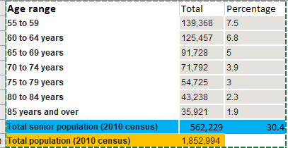
A.

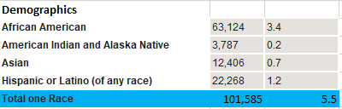
B.

(Source: 2010 United States Census, https://factfinder.census.gov/faces/tableservices/jsf/pages/productview.xhtml?pid=DEC_10_DP_DPDP1&prodType=table)

Even with the overall population of minority demographics representing 5.5 % of the entire state, WV Local SCSEP projects are able to capture a high percentage of minority representation. Table 8 illustrates the minority representation currently in the program, captured from the SPARQ database.

Table 8
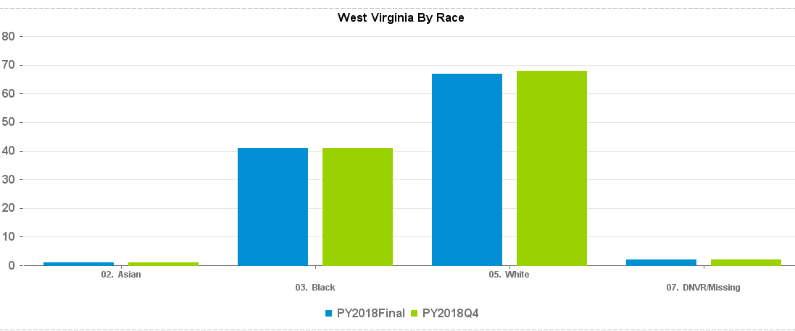

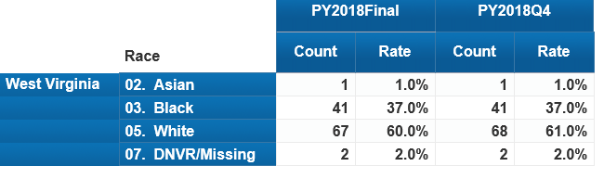

(Source InfoSPACE, Grantee by Dimension, Race, PY 2018 Final)

Community Service Needs

SCSEP has a two-fold approach: helping Older Americans reacclimate themselves back into the workforce with the skills and training needed to be more marketable in the workforce and helping the communities that the program is in. The participant training hours support social services and other services provided in communities throughout the State.

West Virginia’s top occupations per the West Virginia Workforce, Labor Market Information (LMI) 10-year projections of high demand occupations that require minimum education that fit our SCSEP participants’ education and training levels include the following:

    - Bus Drivers, Transit and Intercity
    - Customer Service Clerks
    - Social and Human Service Assistants
    - Community Health Workers
    - Animal Caretakers
    - Post-Secondary School
    - Personal Care Aides
    - Home Health Aides
    - Rehabilitation
    - Janitors
    - Counter Attendants

With these projections, Host Agency (H.A.) training site recruitment will focus more on entities that will develop skills for these high demand jobs. Also, to ensure that SCSEP’s two-fold approach is being accomplished, local SCSEP projects will continue to research non-profits and Government agencies in the counties that are covered to asses if there is a need. Recruitment of entities such as the West Virginia Department of Agriculture where they have programs such as Veterans and Warriors to Agriculture and Rural Rehabilitation programs that need participants will be utilized.

Recruiting of Host Agencies (H.A.) is currently accomplished by relationships with past and current H.A., great rapport with the American Job Centers (AJC’S), attending meetings, community events, job fairs, health fairs and presenting on behalf of SCSEP. Other avenues of recruitment include marketing campaigns, where Project Directors market SCSEP services and the skills of job ready participants to organizations. Word of mouth is also utilized to recruit host agencies.

Local SCSEP projects will continue to utilize Senior Centers, Aging & Disability Resource Centers (ADRN), OAA programs, AJC’s, and one-stop partners to determine the need in the counties and will continuously refine the strategy for job development to guide employer outreach and participant readiness.

Long-term Strategy to Improve SCSEP Services

The strategy to improve SCSEP services within the State is to do the following:

    - Marketing Campaign- not only disseminate information regarding SCSEP but also promote the program at key meetings to educate organizations of the Mission and Vision
    - Reach out to hiring entities to discuss SCSEP
    - Exchange information regarding eligible Older Workers with AJCs
    - AJCs become H.A.
    - Encourage cross training in training opportunities for enrollees
    - Inclusion within the WIOA State Plan
    - Provide more incentives, such as drug screenings, criminal background checks for hiring entities
    - Develop relationship with State DHHR to improve requirements for SCSEP target audience (i.e. Medicaid allotment of income)
    - Revise goals with DOL to reflect actual program funding
    - Increase funding to provide more trainings for enrollees
    - Increase H.A. recruitment for a variety of training opportunities

These recommendations will strengthen the SCSEP program within the State, affording not only potential and current enrollees’ opportunities, but also strengthening the organizations that work with the program.

Regarding the long-term changes in the use of grantee and program operators to better achieve goals, the SCSEP network, with its sub grantees, continuously refines its expertise on the basic elements of job development by staying abreast of the many barriers that eligible enrollees face. By trying to alleviate these barriers, Sub-Grantees are continuously assessing skills of participants, revamping Individual Employment Plans, offering additional resources, preparing for exit, resume revamping through workshops and offering one-on-one interaction with SCSEP Staff. As new barriers arise, grantee staff will adapt and provide resources.

Strategy for Continuous Improvement in Entered Employment of Performance

The entered employment performance goal continues to be a challenge. During PY 18, the Core Performance measures were revamped from being measured as Common Measures Entered employment and Common Measure Employment Retention to now Employment Rate 2nd and 4th quarter after exit. This major change came about with the Interim Final Rule (IFR) SCSEP Performance Accountability that was issued by USDOL/ETA on December 1, 2017. The purpose of the New Core Measures appears to be an alignment of SCSEP performance data with Workforce Innovation and Opportunity Act (WIOA) performance data to provide usable data comparisons between the programs. Prior to the adjustment, the rate of meeting the projected goals fluctuated. Table 9 reflects the variance during each PY.

Table 9
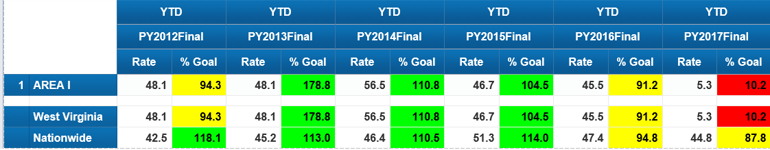
(Source: Infospace, Core measures, entered employment Sub-grantee)

After the modification of the goals, it was evident that the employment goal/retention needed much improvement and was a barrier that the program faced. During PY18, the target goal that was set forth by DOL during the 2nd quarter after exit was 41.7% and the 4th quarter after exit goal was 35.6%. Table 10 reflects the performance during the final quarter of PY 18.

Table 10
Measure | Goal | Rate | % of Goal Met
Employment Rate 2nd Quarter after Exit | 41.7% | 14.3%  N= 5  D=35 | 34.3%
Employment Rate 4th Quarter after Exit | 35.6% | 8.0%  N=2  D=35 | 22.5%
(Source: Quarterly Progress Report. PY18 Final)

Due to the performance during PY18, our approach moving forward is to ensure that the program, specifically the employment aspect of the program, has continuous improvement. The following strategy must be implemented:

  - Ensure that Sub-Grantees are aware of the LMI high-demand positions
  - Provide adequate training for enrollees
  - Increase accountability of job search log of enrollee
  - Continue and increase partnerships with hiring entities to ensure that enrollees are being considered
  - Increase H.A. sites to provide a variety of training opportunities
  - Collaborate with other employment programs
  - Increase program outreach and program resources
  - Revamp individual employment plan (I.E.P) of individuals to ensure job search complies with employment plan

Another barrier that was identified is the majority of SCSEP’s target audience have supplemental insurance, reside in subsidized housing, and/ or receive Social Security Benefits, and because of this factor, the likelihood of them obtaining employment at the completion of the program is very slim. This is due to the fear that benefits will be lost and adjusted. Another strategy would be educating enrollees regarding employment and their current benefits. Eligible seniors want to work but are apprehensive.

SECTION 4. Location and Population Served, Including Equitable Distribution

Localities and Populations Most in Need of the Type of Projects Authorized by Title V
Most recent West Virginia U.S. Census data shows the 2010 total population for the state of WV at 1,852,994. The population of individuals who are the SCSEP target audience, 55+, shows 562,229, which is 30.4 % of the total population. Of this population, an estimate of 27.7% are at poverty rates for families and people for whom poverty status is determined.

WV partners with a plethora of State and non- profit organizations that play the role of Host Agencies (H.A.). Majority of our H.A. are unable to hire additional help within their organizations due to the limit in funding, but they express that help is needed. H.A. range from local municipalities to State agencies to a local YMCA. All H.A. are essential to the overall success of the program, as they provide the hands-on training that is needed and vital to the program.

Within the SCSEP, priority of service is offered to the following individuals:
o Veteran or a Spouse of a Veteran
o 65 Years or Older
o Has a Disability
o Has Limited English Proficiency
o Low Literacy Skills
o Resides in Rural Area
o Low Employment Prospects
o Homeless or At Risk of Homelessness
o Failed to Find Employment After Utilizing Services Provided Under Title I
o Severely Low Employment Prospects and Living in an Area of Persistent Unemployment

Equitable Distribution Changes from Prior Year

Within West Virginia, there were two SCSEP providers covering 451 authorized positions during PY18. Modified positions during PY18 were 367 statewide. Currently, West Virginia has one National Grantee, National Council on Aging, and one State Grantee, West Virginia Bureau of Senior Services, that comprise the Statewide SCSEP Network. These grantees are experienced SCSEP administrators and are respected, capable partners. The Sub Grantee has created well-established relationships with host training sites, employers, supportive service resources and training providers.

Among these providers, they cover all 55 counties in WV. The distribution of authorizations is based on the Equitable Distribution as provided by U.S. DOL, which identifies each county’s percentage of the state’s program-eligible population.

In 2016, SCSEP held a national competition, which resulted in one National Grantee being eliminated. Due to the elimination of the National Grantee, slot allocations changed, and the National Grantee, NCOA inherited all allocated slots of the eliminated National Grantee. Table 11 represents the Authorized Positions that each grantee had for the past four Program Years. Table 12 goes more in-depth, showing how the counties are distributed among the 55 counties that are covered in West Virginia.

Table 11
Grantee | 2016 Q4 Authorized Positions (AP) | 2016 Q4 Modified Positions  (MP) | 2017 Q4  AP | 2017 Q4  MP | 2018 Q4  AP | 2018 Q4  MP | 2019  AP | 2019  MP
NCOA | 391 | N/P | 358 | 291 | 359 | 292 | 360 | 293
STATE | 100 | 83 | 92 | 75 | 92 | 75 | 92 | 75
(Source-Information obtained from SCSEPed.org Authorized and Modified Positions by State Q4)
*N/P- Not provided

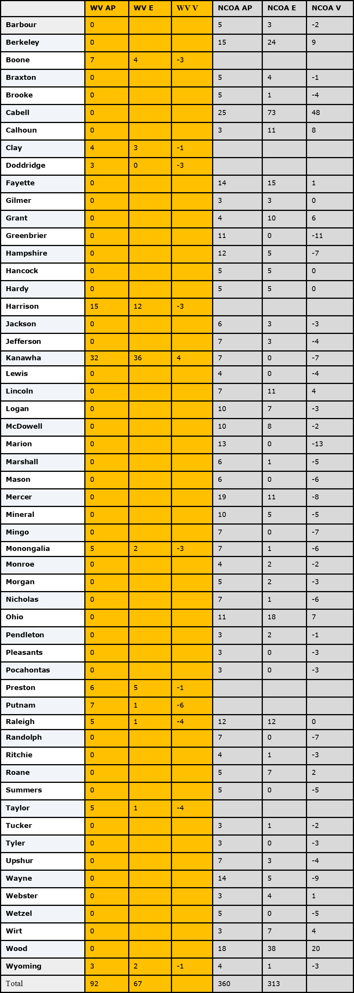
Table 12

(Source: SCSEPED.org, WV, PY 19)

Equitable Distribution Imbalances and Corrective Steps

Equitable distribution imbalance is caused by many factors, as shown below, that cause a variance in the slots in the Statewide SCSEP Network. The main variance factor in West Virginia is minimum wage. Due to the rising minimum wage and funding, the number of participants who can be assisted are affected by this factor, and slots must be adjusted. In order to achieve the Modified Positions goal with the factors at hand, the SCSEP Network would have to minimize participant hours to accommodate more participants.

Another cause for imbalance/variance is the State’s layout. Majority of our counties are categorized as rural counties and because of this, there are many barriers such as:

- Transportation
- Limited training site opportunities
- Limited hiring entities
- Over income seniors
- Small applicant pool
- Unaware of program

As a State, we want to ensure that we are fully enrolled and want to minimize any variance in SCSEP’s equitable distribution enrollee count. How we will attain this goal is by continuing partnership with local WorkForce offices, continue and increase outreach in areas that are under enrolled while curtailing areas that are over enrolled and begin the discussion of interchanging information among National and State Grantees to fulfill the equitable distribution of all urban and rural counties that are under enrolled.

The State’s Long-Term Strategy for Achieving Distribution of SCSEP Positions within the State

West Virginia is divided into 55 counties. The State and National Grantee covers 13 urban counties collectively, with the remaining counties being consider rural. Based on the 2016-2018 Persistent Unemployment data, 36 of the 55 counties in West Virginia are considered having persistent unemployment. Of the 42 rural Counties, 31 show as having persistent unemployment. As stated previously, rural communities face a multitude of barriers. To alleviate the imbalances, the SCSEP Network will continue and increase outreach (i.e., brochures, posters, partnerships and presentations) efforts in the rural counties to ensure that non-profits and government entities are aware of the program.

The State of West Virginia SCSEP Grantee has no authority to move national grantee positions within the state; however, constant contact is maintained with the National. Conversations and recommendations to alleviate variances will continue to be discussed within the statewide SCSEP Network.

Program regulations require SCSEP Grantees to give priority service to individuals with one or more of the following characteristics:

  - Veteran or a Spouse of a Veteran
  - 65 Years or Older
  - Has a Disability
  - Has Limited English Proficiency
  - Low Literacy Skills
  - Resides in Rural Area
  - Low Employment Prospects
  - Homeless or At Risk of Homelessness
  - Failed to Find Employment After Utilizing Services Provided Under Title I
  - Severely Low Employment Prospects and Living in an Area of Persistent Unemployment

The statewide SCSEP Network employs the following tactics to ensure that individuals who meet the criteria above are targeted:

  - Outreach Materials (brochures and posters) are strategically placed at locations that target our priority of service audience (i.e. Veteran’s Hospitals, shelters, library, rehab disability office etc.)
  - Locates offices in culturally and ethnically diverse neighborhoods
  - Targets AJC’s
  - Presents and collaborates with entities that target low income populations
  - Collaborates with National on successful tactics utilized

Ratio of Eligible Individuals in Each County and State Total Eligibility Population

Tables 13 depicts the ratio by percentage of eligible individuals in each service area to West Virginia’s total SCSEP eligible population.
(Source: https://factfinder.census.gov/faces/tableservices/jsf/pages/productview.xhtml?pid=ACS_17_5YR_B17024&prodType=table
AGE BY RATIO OF INCOME TO POVERTY LEVEL IN THE PAST 12 MONTHS)

Table 13-Ratio as a Percentage of Eligible Individuals in Each Service Area

(Source: https://factfinder.census.gov/faces/tableservices/jsf/pages/productview.xhtml?pid=ACS_17_5YR_B17024&prodType=table AGE BY RATIO OF INCOME TO POVERTY LEVEL IN THE PAST 12 MONTHS)

Relative Distribution of Eligible individuals
West Virginia continuously utilizes resources to ensure relative distribution is provided to specific individuals throughout the state. Tables 14-18 illustrates the variation of characteristics that are barriers to employment throughout the state, such as rural locations, greatest economic (income) and social need (75+, language barrier, live alone), limited English proficiency and minority rate in West Virginia. The SCSEP Network will continue its efforts in recruiting these individuals who are most in need of SCSEP benefits and priority of service. The SCSEP network’s main goal is to ensure that adequate training is provided to current and past enrollees by providing substantial training opportunities to those most in need to ultimately have the enrollees leave the program more equipped than when they started.

Table 14- depicts 55+ Races in all West Virginia Counties
(Source: U.S. Census Bureau: ACS B01001A-E, I 5yr Est. 2017)

(Source: Census Bureau, AFF, B01001A-I, ACS 5 yr. est. 2013-2017)
(Source: Census Bureau P2 urban/rural, P1 Total population 2010, Table DP02 ACS 5yr disability & living alone, Table B01001 ACS 75+)
Table 15- Greatest Social and Economic Need all Counties
(Source: Census Bureau ACS S2301
Table 16 Unemployment Rate 55+ all Counties
Table 17: Limited English Proficiency all Counties

(Source: B16004: AGE BY LANGUAGE SPOKEN AT HOME BY ABILITY TO SPEAK ENGLISH FOR THE POPULATION 5 YEARS AND OVER - Universe: Population 5 years and over)
******for this instance, only 65+ data (except the Total column) was used to better represent our target audience
Table 18 A- Selected Health Outcomes & Demographics Among West Virginia Residents 55+ by County 2014-2018
* Estimates are unreliable due to confidence intervals wider than 20% or relative standard error greater than 30%.
Percentages are calculated with unknowns removed.
Table 18B
(Source Table 18A-B West Virginia Health Statistics Center, Behavioral Risk Factor Surveillance System)

Avoid Disruptions

In the event new providers are entered into the state, be it National Grantee or State Grantee, we will utilize the Equitable Distribution to ensure that slots are distributed to all grantees. To avoid disruptions to current participants, a conversation with all affected Grantees in the state will be required. Counties with continuous variances will be considered. For a seamless transition, enrollees will be transferred in the SPARQ database, which will allow the avoidance of disruption in service. Per Topic 81 of the SCSEP Data Collection Handbook, all records moved from the “old grantee” to the new are subject to data validation. During the transfer, we will ensure that all supporting documentation is sent via trackable delivery to the “new” grantee.

APPENDICES

Appendix A -West Virginia Area Agencies on Aging
West Virginia's four Area Agencies on Aging (AAAs) are part of a nationwide network of organizations created by the Older Americans Act for the purpose of developing a comprehensive and coordinated plan that assures seniors have access to needed services and programs. The AAAs contract with county aging providers (senior centers) for the provision of meals, transportation, and other services. They also monitor the providers for programmatic and fiscal compliance.
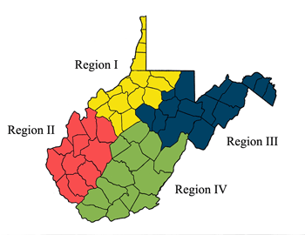

Region I Northwestern AAA- Lynn Williams Dipasquale, Executive Director
Counties Served: Brooke, Calhoun, Doddridge, Gilmer, Hancock, Harrison, Marion, Marshall, Monongalia, Ohio, Pleasants, Ritchie, Tyler, Wetzel, Wirt, Wood

Region II Metro AAA – Brenda Landers, Executive Director
Counties Served: Boone, Cabell, Jackson, Kanawha, Lincoln, Logan, Mason, Mingo, Putnam, Roane, Wayne

Region III Upper Potomac AAA – Scott Gossard, Executive Director
Counties Served: Barbour, Berkeley, Grant, Hampshire, Hardy, Jefferson, Lewis, Mineral, Morgan, Pendleton, Preston, Randolph, Taylor, Tucker, Upshur

Region IV Appalachian AAA – Ramona McNeely-Stanley, Executive Director
Counties Served: Braxton, Clay, Fayette, Greenbrier, McDowell, Mercer, Monroe, Nicholas, Pocahontas, Raleigh, Summers, Webster, Wyoming

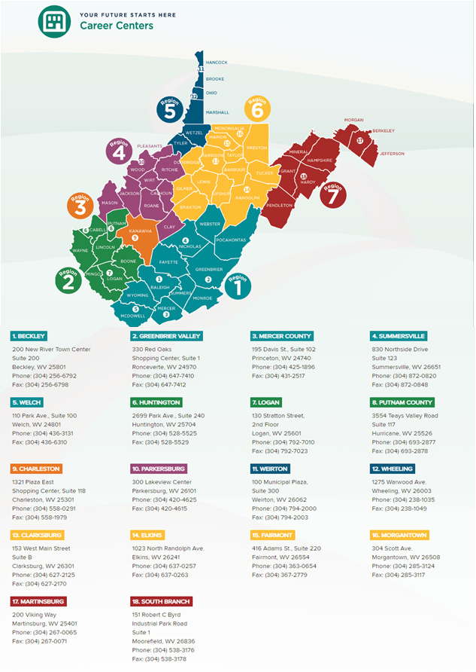
Appendix B- Workforce WV Development Board

Appendix C- Delegation of Authority State Plan Letter

State of West Virginia
Delegation of Authority
State Plan
Senior Community Service Employment Program

I, Jim Justice, Governor of the State of West Virginia, hereby grant authority to Robert E. Roswall, Commissioner of the West Virginia Bureau of Senior Services, to sign and submit, on my behalf, the Senior Community Service Employment State Plan as specified by the U.S. Department of Labor in 20 CFR, Subpart C, Section 641.310.

The West Virginia Bureau of Senior Services is designated by the Federal Administration on Aging as the official State Unit of Aging responsible for the administration of programs funded under the Older Americans Act of 1965, as amended in 2006, and will ensure all requirements are met.

This Delegation of Authority shall be in effect until rescinded.

Jim Justice, Governor Robert E. Roswall, Commissioner

_____________________
Date

Appendix D- Public Comments

Public Comments

Appendix E- Occupational Demand

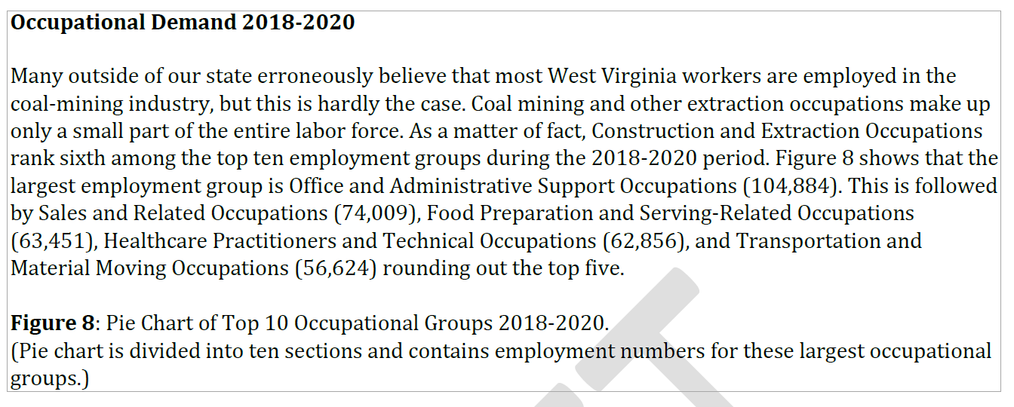

Appendix F- Top 15 Occupations in Demand
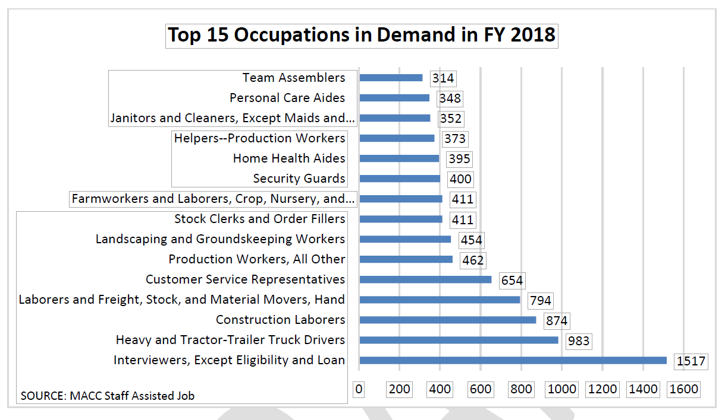

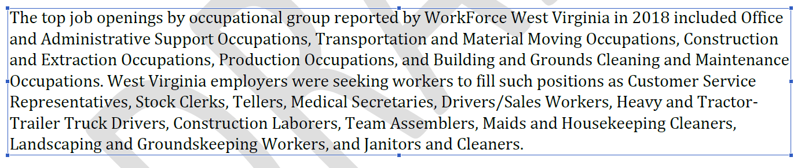

Appendix G- Population by Age Group

(Source ACS 2013-2017)

Appendix H – Labor Force Participation by Age Group
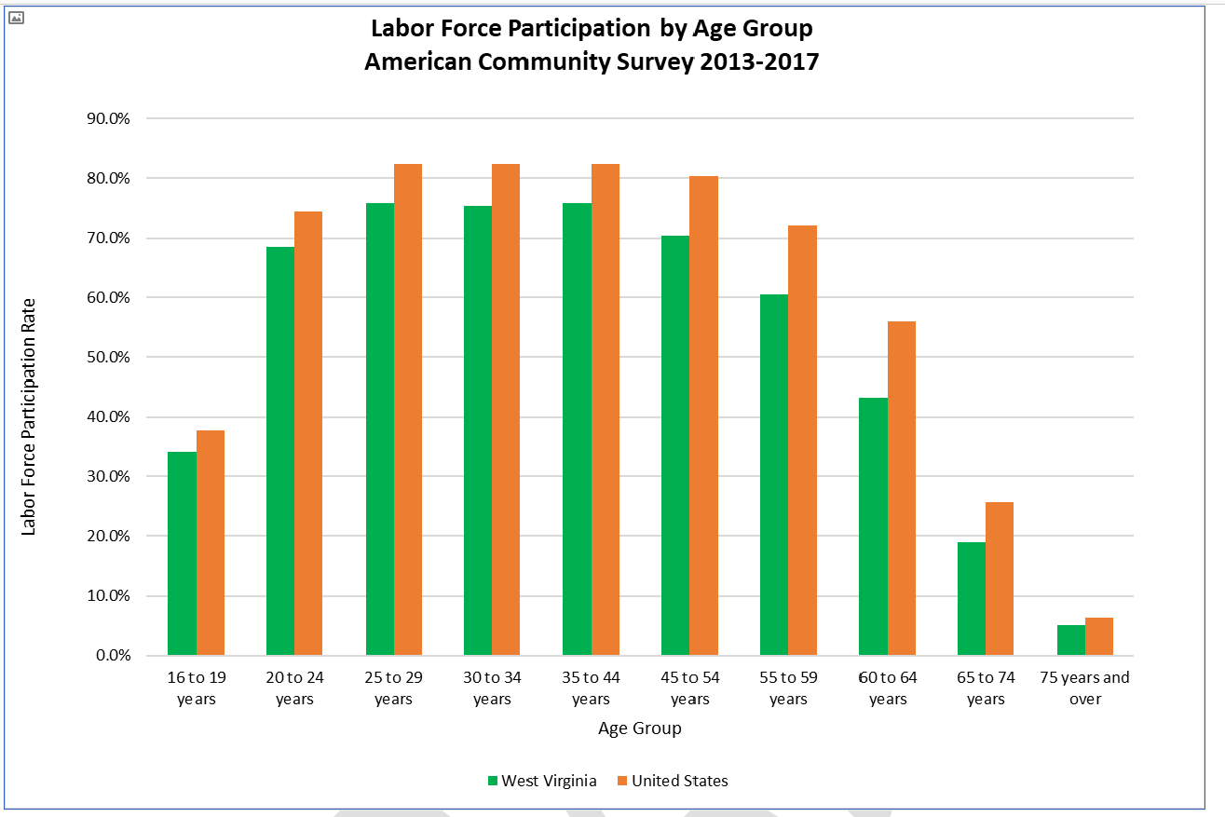

(Source: AMS 2013-2017)
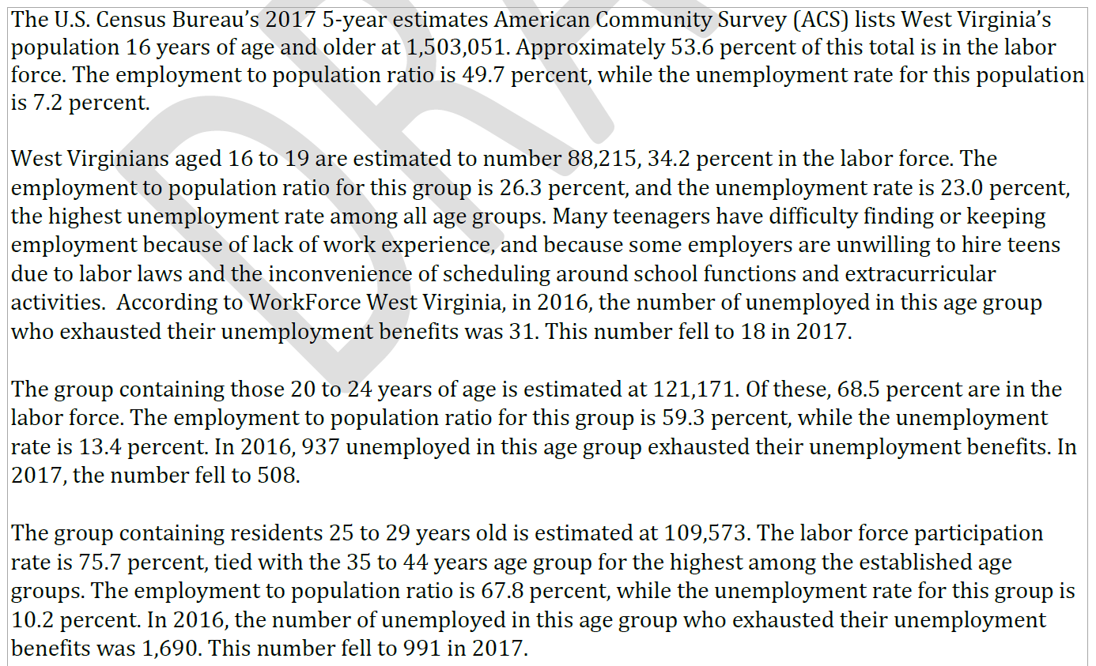

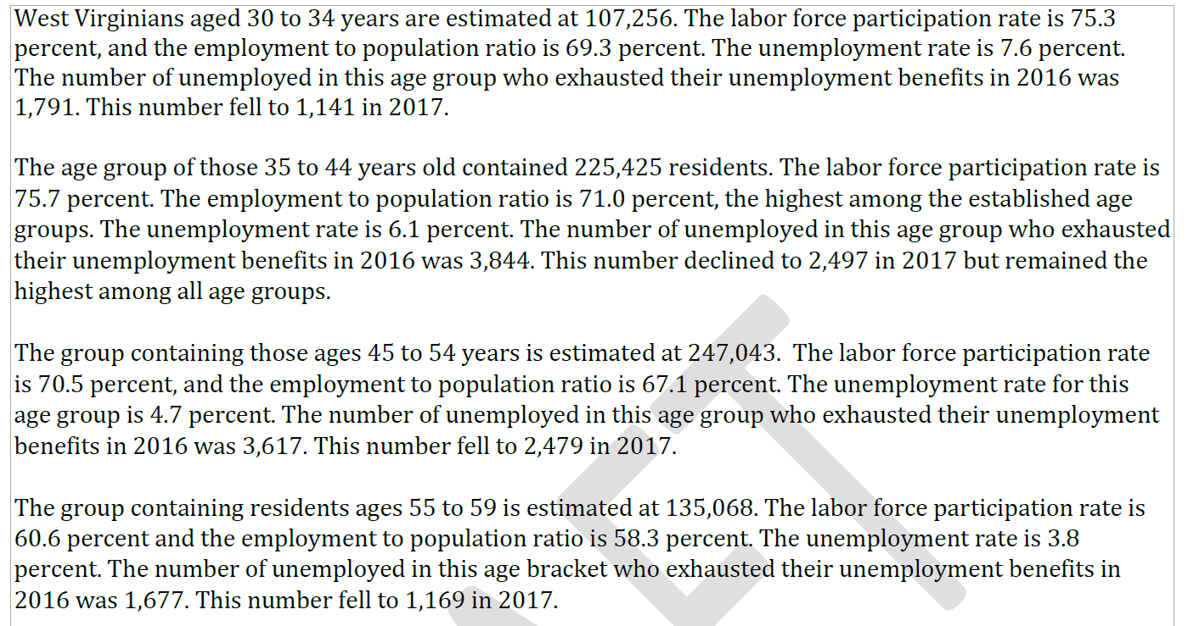

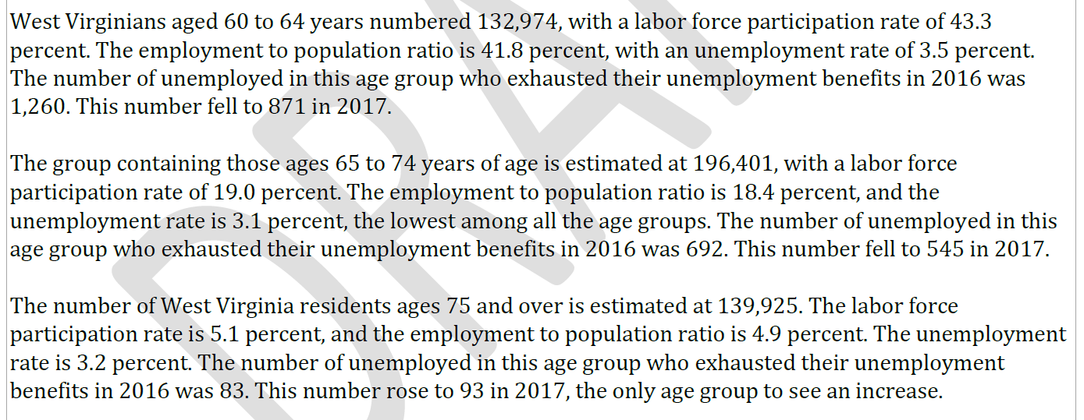

Appendix I- Average Turnover Rate by Age

