July 29, 2019

The Honorable Mac Warner
Secretary of State
1900 Kanawha Boulevard, East
Charleston, WV 25305

Dear Secretary of Warner:

The West Virginia Department of Agriculture is requesting to withdraw legislative rule Title 74CSR1 Dangerous Wild Animal. Thank you for your attention to this matter.

Sincerely,

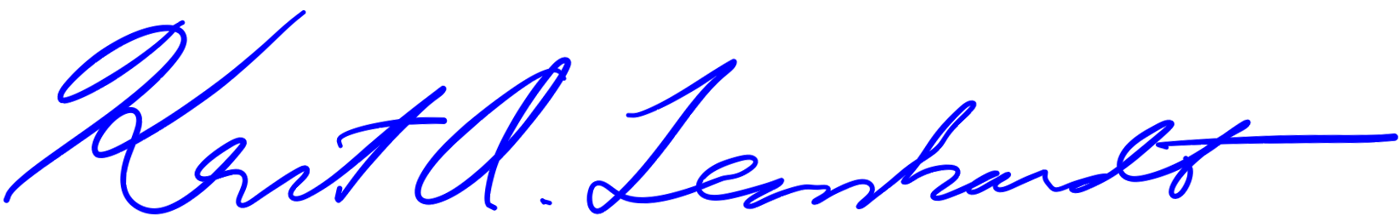

Kent A. Leonhardt
Commissioner

KAL/jfm

