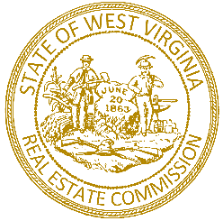

CHERYL L. DAWSON, CHAIRMAN
HURRICANE

JAMES S. WALKER
MORGANTOWN

STATE OF WEST VIRGINIA
REAL ESTATE COMMISSION
300 CAPITOL STREET, SUITE 400
CHARLESTON, WV 25301
(304) 558-3555
FAX (304) 558-6442
<rec.wv.gov>
DENSIL L. NIBERT
SHENANDOAH JUNCTION
SECRETARY

ROBERT KENNEN
WHEELING

JERRY A. FORREN
EXECUTIVE DIRECTOR

Ms. Judy Cooper
WV Secretary of State
State Capitol Building
Charleston, Wv 25305

The West Virginia Real Estate Commission received no comments during the comment period for proposed Rule 174-6, APPLICATION FOR WAIVER OF INITIAL LICENSING FEES
FOR CERTAIN INDIVIDUALS.

Should you require any additional information, please do not hesitate to call or email our office.

Sincerely,

Jerry A. Forren
Executive Director
West Virginia Real Estate Commission

