July 27, 2018

Mr. Gary Foster
Assistant Chief – Game Management/WV DNR
Wildlife Resources Section
Post Office Box 67
738 Ward Road
Elkins, WV 26241
Dear Mr. Foster:
Thank you for your recent comment regarding the West Virginia Department of Agriculture’s legislative rule Title 61CSR1 Animal Disease Control, and Title 61CSR34 Captive Cervid Farming.
The following changes have been made to 61CSR34 to reflect your suggestions:
- In section §61-34-2 2.20 the definition has been changed to clarify that captive cervid are not wildlife.
- In section §61-34-12 12.2 the extra period has been deleted.
The following changes have been made to 61CSR1 to reflect your suggestions:
- In section §61-1-3 3.22 the reference to W. Va. Code has been removed until further research is completed.
- In section §61-1-5 5.2 the words “release” and “The Intentional” have been added.

Sincerely,
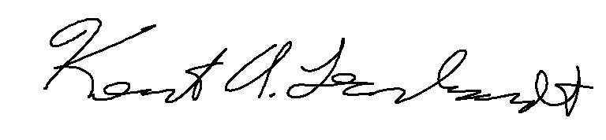
Kent A. Leonhardt
Commissioner

