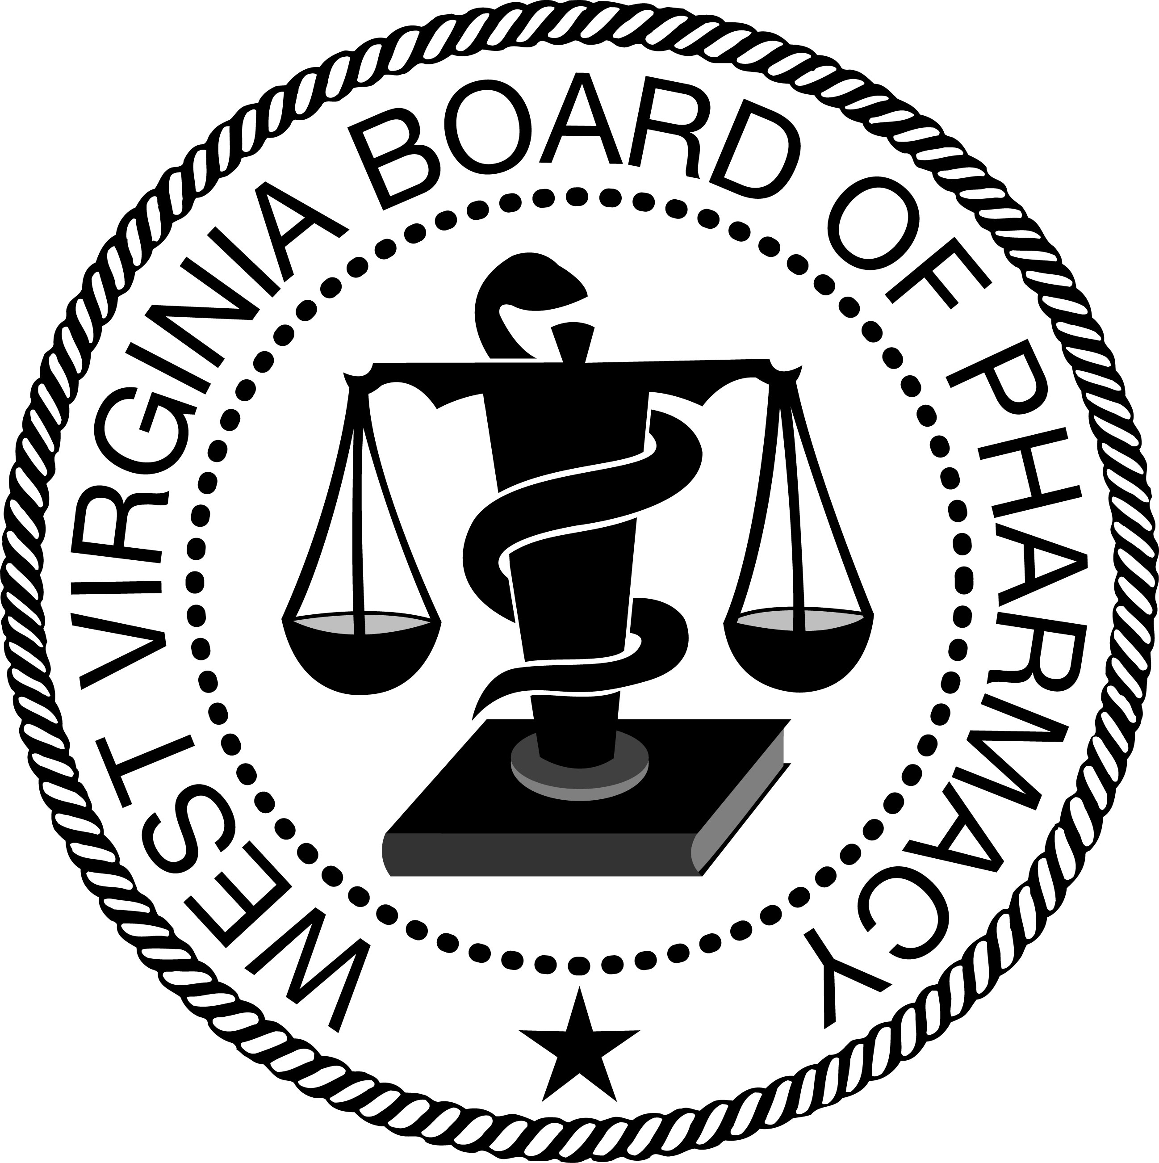
BOARD MEMBERS STAFF
John J. Bernabei Michael L. Goff,
Everett Frazier * Acting Executive Director &
Chuck Jones* CSMP Administrator
Sam Kapourales
David Bowyer John Smolder
Dennis Lewis CFO/COO
Vicky Skaff
(*Public Member)

Office Address Phone
2310 Kanawha Blvd, East www.wvbop.com (304) 558-0558
Charleston, WV 25311 (304) 558-0572 (fax)

RESPONSE TO PUBLIC COMMENTS RECEIVED
TO PROPOSED RULES
(Including explanation of any amendments made to the proposed rule as a result of comments)

TITLE 15, SERIES 10
PHARMACIST RECOVERY NETWORKS

The Board of Pharmacy filed proposed rules with the Secretary of State on May 12, 2017, making amendments to Title 15, Series 10. The public comment period ended on June 12, 2017, at 4:00 p.m. The Board received no written public comments regarding the rules. The Board held a public meeting on June 26, 2017, to review any comments. Given no comments were received, no further substantive changes were made.

The Board then authorized this response and the proposed rules to be filed with the Secretary of State and the Legislative Rule-Making and Review Committee.

Prepared by:

_________________________________
Michael L. Goff
Acting Executive Director

