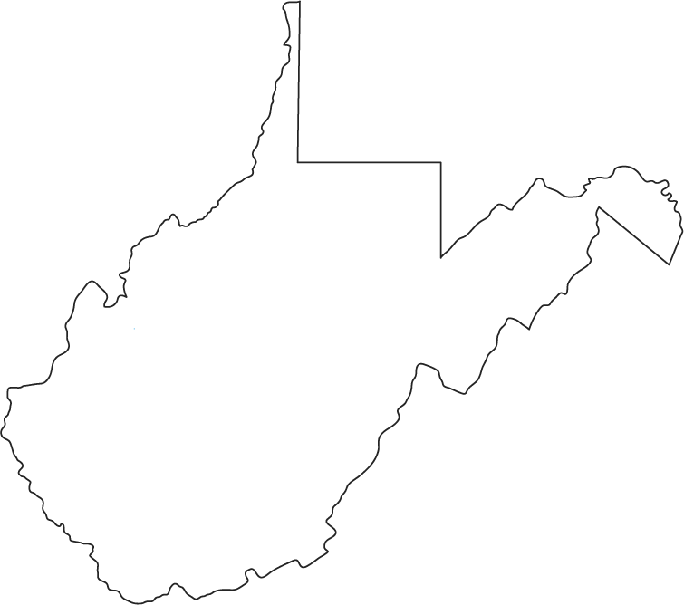

WEST VIRGINIA BOARD OF COAL MINE HEALTH AND SAFETY

1900 Kanawha Blvd Bldg 6 Ste 645 Charleston WV 25311 304.957.2306

NOTICE: PROMLUGATION OF LEGISLATIVE EXEMPT RULE
22 May 2017
To: All persons interested in Rules and Regulations constructed by the Board of Coal Mine Health and Safety
From: Joel L. Watts, Administrator – BCMH&S
Subject: 36.57 – Rules Governing Proximity Detection Systems and Haulage Safety Generally:

Authority: §22A-6-4; Senate Bill 134 of the 2017 Legislative Session.

The Board of Coal Mine Health and Safety is created pursuant to WV Code §22A-6-1

At the 16 November 2013 meeting of the Board of Coal Mine Health and Safety, the Health and Safety Administrator was directed twice to write rules towards the use of proximity detectors and other avenues of safety in underground coal mines. On 12 December 2013, in response to the fatality of Mr. Steven A. O’Dell, the Board of Coal Mine Health and Safety voted to pursue rulemaking to prevent the reoccurrence of similar fatalities and to include based on the maturity of the technology, the use of proximity detection equipment.

A public subcommittee of the Board met 6 January 2014 to finalize a draft proposed rule which was in turn presented at the 16 January 2014 meeting of the Board. The comment period ended 11 March 2014. A final rule was deliberated and unanimously passed at the 9 April 2014 meeting.

During the 2017 session, the West Virginia State Legislature directed “the Board of Coal Mine Health and Safety, pursuant to the authority given to the board in section four, article six, chapter twenty-two-a of this code, to promulgate the legislative rule filed in the State Register by the Board of Coal Mine Health and Safety on July 1, 2014, relating to rules governing proximity detection systems and haulage safety generally, (36 CSR 57), with the amendment set forth below:

On page two, subsection 4.3, by striking out the date ‘July 1, 2017’ and inserting in lieu thereof the following ‘the timeframe set forth in the federal rule relating to proximity detection systems.’”

During the 11 May 2017 Board meeting, the Board voted to amend the rule as directed as well as include a one-time extension for final implementation. As part of this amendment process, the Board directed the Director of the Office of Miner’s Health, Safety, and Training to issue a letter to this end. It is attached to the final copy of this rule.

The staff of the Board of Coal Mine Health and Safety cannot issue interpretations or best practice procedures. For questions related to the application of this rule, please call 304.558.1425.

Thank you,

Joel L. Watts
Health and Safety Administrator
Board of Coal Mine Health and Safety

